Dear [VENDOR NAME]
I’m [NAME] from [PHARMACY/ORGANIZATION] — I’m a customer of yours, and I need your help. To get to the point, my patients are facing a threat to their medication — one that is also a threat to my business. It can be stopped, but I need your support to make that happen.
FDA could restrict my patients’ access to compounded hormone therapy, and my ability to provide it to them. I suspect this is an issue you will agree deserves your attention … and your assistance.
In terms of a brief background, an FDA-funded report from the National Academies of Science, Engineering, and Medicine recommended across-the-board restrictions on compounded hormones – which make a substantive portion of my compounding business. Unfortunately, that report has now been shown to be rife with flaws in methodology, and improperly influenced by FDA.
Even worse, the NASEM report (a FOIA request discovered) was also inappropriately and possibly illegally manipulated by FDA through influence in the committee’s structure, function, and recommendations – manipulations that render the report practically worthless. You can find details of the problems with the NASEM study, and an overview of the cBHT threat, at A4PC.org/cbht.
Despite this, FDA issued a public statement saying it would base its next steps on compounded hormones on that report – a statement widely interpreted to mean FDA will act to restrict compounded hormone therapy.
Make no mistake: This is not only a clear threat to patients’ well-being, in many cases it’s an existential threat to the compounding pharmacies you work with, including mine.
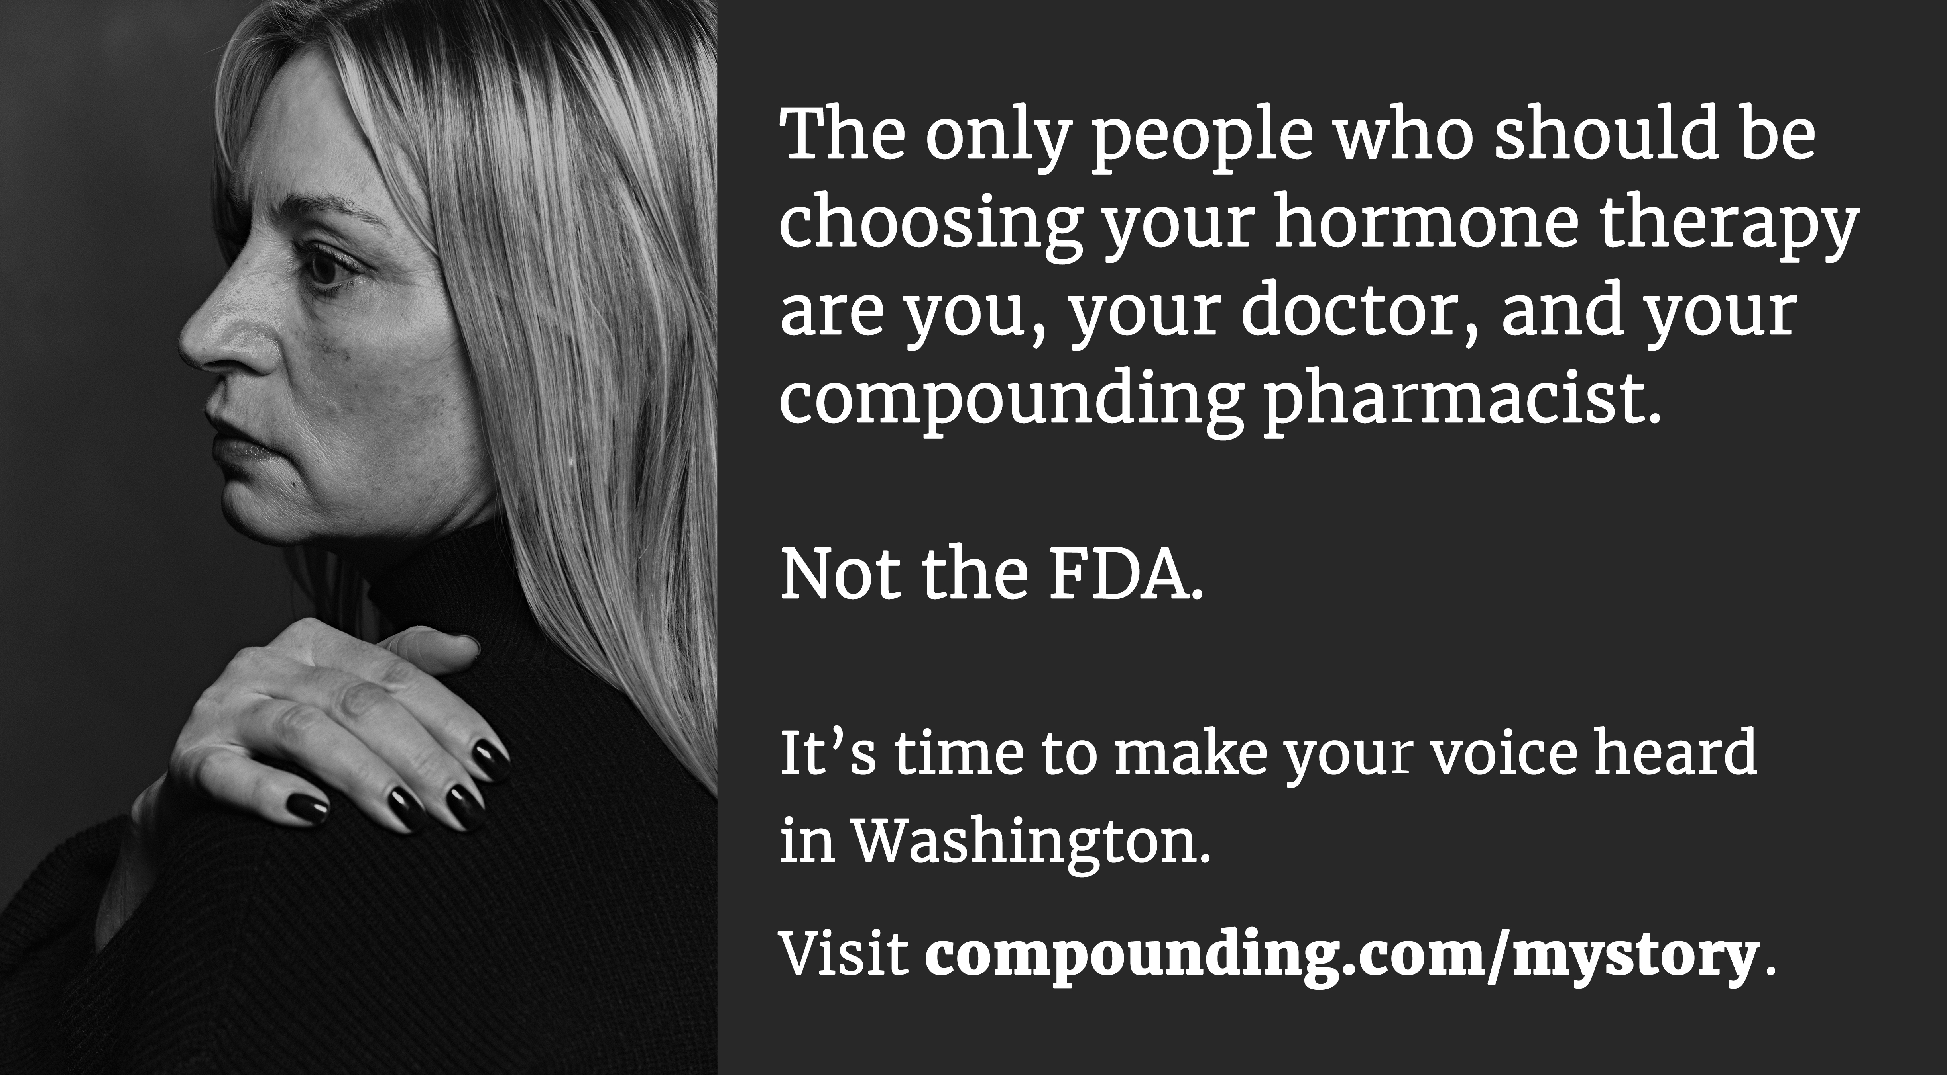
With this in mind, the Alliance for Pharmacy Compounding is mounting a $1.5 million communications campaign to engage patients, prescribers, pharmacists, and policymakers in hopes of preventing irresponsible limitations to the therapies that many patients rely on for their quality of life.
The campaign, which launches this month, will feature the human face of compounded hormones: the millions of patients for whom manufactured hormones are not suited and who benefit daily from compounded hormone therapy.
The campaign will include digital advertising, sophisticated online engagement technology, social media influencer outreach, patient-facing resources for pharmacy compounders and prescribers, and connected TV advertising.
It will engage patients in sharing their stories, prescribers in sharing the threat with their patients, and perhaps most importantly, it will educate members of Congress about the benefits of compounded hormones (and this threat to their constituents).
Because compounded hormone therapy is so important to so many of the pharmacies or outsourcing facilities you supply, I believe it’s in your best interest to make a leadership-level investment in this campaign.
Time is of the essence. At this writing, we have raised nearly $900,000 of the needed $1.5 million, and the majority of that has come from individual compounding pharmacy owners. We need your support to fully fund the ad placements it hopes to begin shortly.
You can read more – and invest! – at APC’s cBHT Campaign web page: A4PC.org/cbht.
Thank you for considering seriously this request. Contact me if I may provide more details or make a presentation.
[signature]

