DATE

Dear patient,
I’m writing to let you know about a threat to patients who benefit from compounded hormone therapy (sometimes called “compounded hormone replacement therapy” or “cBHRT” or “cBHT.”).
The Food & Drug Administration has signaled it may consider restricting or even banning the use of compounded hormones, not because they have proven to be unsafe — they’ve benefited patients for decades — but because they haven’t been tested the same way mass-produced hormones products have been.
(You might think that millions of women and men using them for years would be proof, but you aren’t a government agency.)
Several organizations are working to convince the FDA not to restrict these critical medications without good reason. They’re telling FDA that customized, compounded hormone therapy is essential for many Americans whose physicians have determined can’t use mass-produced hormone products.
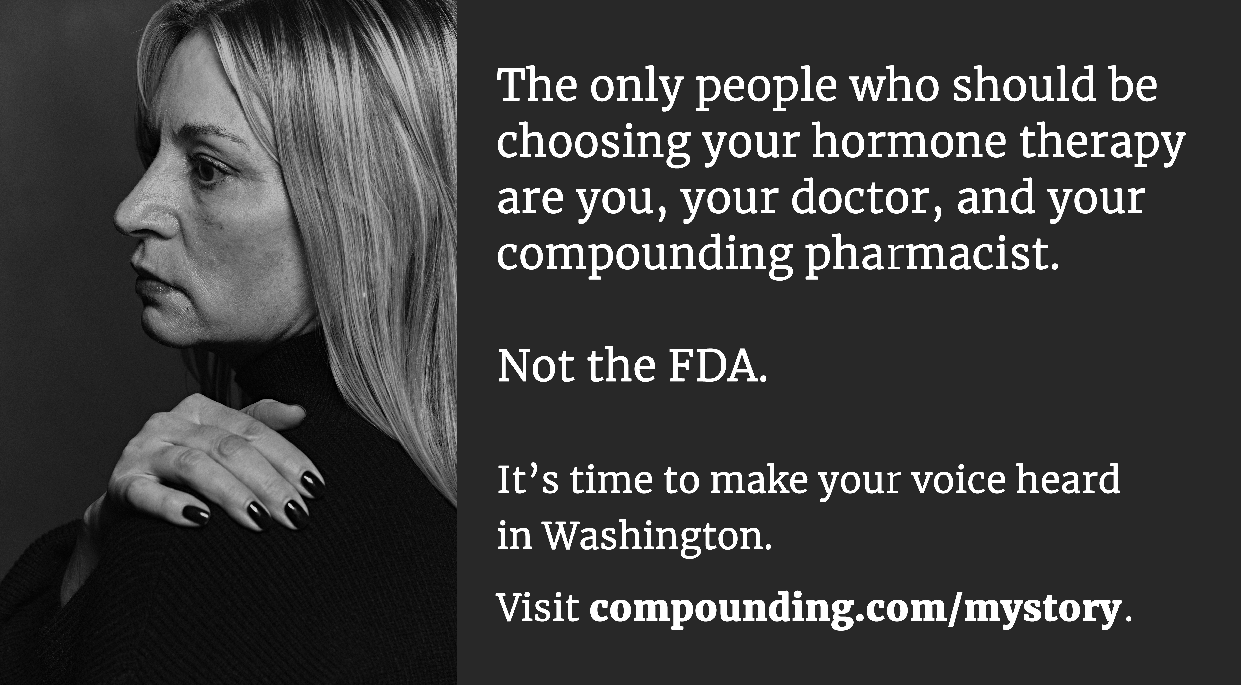
One of them, the Alliance for Pharmacy Compounding, is collecting patient testimonials: the stories of women and men whose lives have been improved by their hormone therapy. They’ll be using these stories as part of a campaign to convince the FDA not to take away this treatment.

What you can do
Very easy: If you or someone you know has benefited from using compounded hormones, share your story. Simply go to compounding.com/mystory.
Every story we collect is more proof that compounded hormones work, and that they are life-changing — and sometimes even life-saving. Please share your story – to help ensure they aren’t regulated away.

[signature]

